TimeGrapher Project Plan
Milestone 1 Draft v0.2
LG Software Architectures Training Program
Team 5 / Archi-265

Team Name | 5조, Archi-265
Team Leader | 윤성준
Team Members | 김준성, 박준영, 백종대, 오선영, 오재홍
Document Purpose | Milestone 1 planning, mentor review, and team alignment
Status | Draft for Paulo mentor meeting
Prepared for mentor discussion and Milestone 1 planning

0. Must-Ask Questions for Paulo Mentor Meeting
The following questions should be discussed first during the mentor meeting. They are selected to clarify project scope, architectural direction, Milestone 1 expectations, and risk-driven planning.
ID | Question | Purpose
Q1 | For Milestone 1, how detailed should our initial architecture diagrams be? | M1 deliverable depth
Q2 | Should our architectural approaches be concrete design decisions, or can they remain candidate approaches with rationale? | Avoid over-committing before experiments
Q3 | There are many mandatory graphs. Should all of them be implemented deeply, or should we define MVP depth for each graph? | Scope management
Q4 | Is our first vertical slice appropriate: Input Source → Buffer → Filtering → A/C Detection → Measurement → GUI → Latency Logging? | Validate architecture-first plan
Q5 | How much refactoring of the baseline TimeGrapher code is acceptable? | Determine safe architecture improvement boundary
Q6 | Is it appropriate to separate audio capture, signal processing, measurement calculation, and GUI presentation? | Validate modular architecture direction
Q7 | Should GUI thread and audio processing thread be separated from the beginning? | Real-time and responsiveness strategy
Q8 | Can WeiShi 1000 be used as a reference device for validating rate, amplitude, and beat error? | Measurement correctness reference
Q9 | What tolerance should we use for rate, amplitude, and beat error accuracy? | Measurable QA criteria
Q10 | Is there a target threshold for acceptable end-to-end latency? | Latency response measure
Q11 | Can our team define dropped audio block and missed beat metrics if not explicitly specified? | Metric definition
Q12 | Can initial experiments be performed on PC and then revalidated on Raspberry Pi? | Practical experiment sequencing
Q13 | What is the minimum acceptable AI/TinyML proof of concept? | Avoid AI scope creep
Q14 | Should requirement ambiguity questions be sent to Jason/Steve while mentor meeting focuses on architecture trade-offs? | Question routing
Q15 | What is the most important architecture risk you think our team should watch first? | Mentor guidance
Meeting note
- Start with Q4 to confirm the team’s architecture-first strategy.
- Use Q3, Q8, Q9, and Q10 to convert ambiguous requirements into measurable planning assumptions.
- Record answers as assumptions or decisions in the Milestone 1 document.

1. Project Overview

1.1 Purpose
This project aims to enhance the baseline mechanical-watch TimeGrapher into a Raspberry Pi-based real-time diagnostic and visualization system. The system captures acoustic signals from a mechanical watch, detects important beat events, computes measurements such as rate, beat error, amplitude, and BPH, and presents the results through an extensible graphical user interface.
This project is treated as a software architecture project. Therefore, the team will focus not only on implementing features, but also on designing a modular, extensible, maintainable, testable, and measurable architecture.

1.2 Objectives
- Advance the baseline TimeGrapher GUI into a real-time diagnostic and visualization system.
- Support signal detection, signal processing, real-time analysis, and real-time graphing.
- Improve measurement correctness, low latency, real-time performance, robustness, and extensibility.
- Plan and execute technical experiments that reduce architectural risk.
- Demonstrate architecture-driven trade-offs through Milestone reviews and the final demo.

1.3 Strategy: Small Vertical Slice First
The team will first validate a small end-to-end vertical slice before expanding to additional diagnostic graphs. This strategy reduces risk early and allows the team to make architecture decisions based on evidence rather than assumptions.
Planned first vertical slice:
Input Source → Audio Buffer → Signal Filtering → A/C Event Detection → Measurement Calculation → GUI Display → Latency and Error Logging

2. Team Organization
The following role distribution is an initial proposal for Milestone 1 planning. Final responsibility assignments should be confirmed by the team after reviewing each member’s preference and technical background.
Name | Initial Role | Responsibility
윤성준 | Team Leader / Architecture Coordination | Owns team coordination, mentor communication, project plan integration, architecture decision tracking.
김준성 | Signal Processing Lead (Proposed) | Analyzes audio pipeline, filtering candidates, A/C event detection feasibility.
박준영 | Measurement Calculation Lead (Proposed) | Owns rate, beat error, amplitude, BPH formula interpretation and validation.
백종대 | GUI / Visualization Lead (Proposed) | Owns graph views, marker display, pause/review interaction, usability improvements.
오선영 | Experiment / Risk / Documentation Lead (Proposed) | Owns experiment templates, risk tracking, QA scenario consistency, documentation updates.
오재홍 | Integration / Raspberry Pi Performance Lead (Proposed) | Owns PC/Pi build, setup, latency/performance measurement, target hardware validation.

3. Milestones and Plan
Milestone | Target Period | Main Goal | Expected Output
Milestone 1 | Week 2 | Plan, drivers, risks, and experiments | Project Plan, Architectural Drivers, Risk Assessment, Planned Experiments, Initial Architecture Approaches
Milestone 2 | Week 4 | Experiment results and architecture design | Experiment Results, Module View, Runtime/C&C View, Deployment View, Updated Construction Plan
Milestone 3 | Week 5 | Final demo and lessons learned | Working TimeGrapher GUI on target platform, QA evidence, Architecture summary, Lessons Learned

3.1 Milestone 1 Definition of Done
- Project scope and priorities are documented.
- Functional requirements are identified and numbered.
- Key quality attribute scenarios are written with measurable response criteria.
- Risks are linked to quality attribute scenarios.
- Planned experiments are linked to risks and architectural decisions.
- Initial architecture approach is documented.
- Candidate ADRs are listed.
- Open questions and assumptions are recorded for mentor review.

4. Scope and Priorities
Priority | Scope Area | Description
P0 | Core architecture and measurement pipeline | Baseline build, input modes, A/C detection, rate/beat error/amplitude calculation, latency logging.
P1 | Required diagnostic views | Enhance Sound Print and Rate/Scope views, implement/prototype high-value diagnostic graphs, pause/review behavior.
P2 | Advanced features | Spectrogram, waveform comparison, synchronized sweep, multiple filter views, AI/TinyML POC, export/logging.

5. Functional Requirements
The following requirements are derived from the project description, kickoff brief, setup instructions, equations document, and reference materials. Priorities are planning priorities for Milestone 1 and may be adjusted after mentor clarification.
ID | Priority | Requirement | Notes
FR-01 | P0 | Support Live, Playback, and Sim input modes. | Required for live measurement, repeatable debugging, and controlled testing.
FR-02 | P0 | Acquire mechanical-watch acoustic signals in real time. | Basis of the target system.
FR-03 | P0 | Support configurable sample rates. | 48 kHz minimum, 96 kHz target, 192 kHz stretch.
FR-04 | P0 | Detect key acoustic beat events, especially A/T1 and C/T3. | A/T1 supports rate and beat error; A/T1 and C/T3 support amplitude.
FR-05 | P0 | Calculate rate, beat error, amplitude, and BPH from detected events. | Follow TimeGrapher equations and clarified assumptions.
FR-06 | P0 | Display current rate, amplitude, beat error, and BPH in the GUI summary area. | Primary user-facing values.
FR-07 | P0 | Display raw or processed waveform data with timing markers. | Supports verification and debugging.
FR-08 | P0 | Record timestamp information at major processing stages. | Needed for latency evidence.
FR-09 | P0 | Identify missed beats, dropped audio blocks, or invalid signal conditions when detectable. | Needed for reliability and error handling.
FR-10 | P0 | Provide status feedback for weak, noisy, missing, or corrupted signals. | Prevents misleading measurements.
FR-11 | P1 | Enhance the existing Sound Print view. | Clearer A/C markers, filtering, averaging, review support.
FR-12 | P1 | Enhance the existing Rate/Scope view. | Raw waveform comparison and marker consistency.
FR-13 | P1 | Support pause and review of captured data without losing the session. | Interactive diagnosis.
FR-14 | P1 | Allow users to move backward and forward through captured signal data. | Detailed inspection of previous beats.
FR-15 | P1 | Support interactive selection of timing points or measurement regions. | Marker-based analysis.
FR-16 | P1 | Implement or prototype Trace Display. | Rate deviation and amplitude over time.
FR-17 | P1 | Implement or prototype Rate and Amplitude Stability display. | Min, max, mean, sigma, elapsed time, current readings.
FR-18 | P1 | Implement or prototype Multi-Position Sequence display. | Position-based comparison.
FR-19 | P1 | Implement or prototype Beat Error Display and Diagnostic Trace. | Graphical interpretation of timing behavior.
FR-20 | P1 | Implement or prototype Escapement Analyzer and Marker-Line display. | Detailed A/C marker inspection.
FR-21 | P1 | Implement or prototype Scope display for beat-noise inspection. | Scope-like waveform inspection and averaging if feasible.
FR-22 | P2 | Implement or prototype Time-Frequency Spectrogram display. | High computational cost, later after performance validation.
FR-23 | P2 | Implement or prototype Waveform Comparison display. | Compare successive beats.
FR-24 | P2 | Implement or prototype Synchronized Sweep display. | Oscilloscope-like real-time sweep.
FR-25 | P2 | Implement or prototype multiple filter views such as F0-F3. | Signal interpretation and feature detection.
FR-26 | P2 | Explore on-device AI/TinyML proof of concept. | Signal quality classification, bad data rejection, user guidance.
FR-27 | P2 | Support saving or exporting recordings, measurements, or logs. | Debugging, repeatability, demo evidence.

6. Quality Attribute Scenarios
The following quality attribute scenarios are prioritized according to architectural impact, project risk, and final demonstration relevance.

QA-01 / Real-Time Signal Processing
Quality Attribute | Performance
Related FR | FR-01, FR-02, FR-03, FR-07
Stimulus | Acoustic audio samples arrive from Live, Playback, or Sim input.
Source of Stimulus | Watch sensor, playback file, or simulator
Artifact | Input pipeline, audio buffer, signal processing module, GUI
Environment | Raspberry Pi target environment during normal operation
Response | The system acquires, processes, analyzes, and displays signal data continuously without visible GUI freeze or processing backlog.
Response Measure | Stable operation at 48 kHz minimum; 96 kHz target; dropped block count and CPU/memory usage recorded.
Importance / Difficulty | High / High
Related Risk | RISK-01, RISK-02, RISK-06
Planned Experiment | EXP-02, EXP-04, EXP-06
Candidate Tactic / Pattern | Producer-consumer queue, buffering, scheduling, reduce computational overhead

QA-02 / Low Latency and Missed Beat Visibility
Quality Attribute | Performance / Responsiveness
Related FR | FR-04, FR-05, FR-08, FR-09
Stimulus | An audio sample block containing watch beat events is captured.
Source of Stimulus | Audio capture module
Artifact | Audio pipeline, event detector, measurement service, GUI renderer
Environment | Raspberry Pi target environment under normal measurement load
Response | The system records stage timestamps and displays the corresponding waveform, markers, and computed values with measurable latency.
Response Measure | Capture-to-processing latency, processing-to-display latency, total latency, average/worst-case latency, dropped block count, and missed beat count are recorded.
Importance / Difficulty | High / Medium
Related Risk | RISK-01, RISK-02, RISK-05
Planned Experiment | EXP-04
Candidate Tactic / Pattern | Stage-based timestamp logging, bounded queue, monitoring

QA-03 / Measurement Correctness
Quality Attribute | Correctness
Related FR | FR-04, FR-05, FR-06
Stimulus | Valid A/C beat events are detected from a controlled signal.
Source of Stimulus | Sim mode, playback data, or reference measurement
Artifact | Measurement calculation module
Environment | Controlled experiment using known BPH, lift angle, and expected signal behavior
Response | The system computes rate, beat error, amplitude, and BPH consistently with the TimeGrapher equations and selected assumptions.
Response Measure | Computed values are compared against simulator parameters, playback reference, or WeiShi reference values. Exact tolerance is TBD.
Importance / Difficulty | High / High
Related Risk | RISK-03, RISK-04, RISK-08
Planned Experiment | EXP-03, EXP-07, EXP-11
Candidate Tactic / Pattern | Single source of truth for formulas, unit tests, regression data

QA-04 / Robustness to Noise and Invalid Signal
Quality Attribute | Reliability / Error Handling
Related FR | FR-09, FR-10, FR-24, FR-26
Stimulus | The input signal becomes weak, noisy, clipped, missing, or corrupted.
Source of Stimulus | Ambient noise, poor microphone coupling, AGC issue, dropped samples
Artifact | Signal processing module, event detector, signal quality monitor, GUI
Environment | Realistic measurement environment with imperfect acoustic conditions
Response | The system avoids producing misleading measurements and clearly communicates signal condition to the user.
Response Measure | Invalid signal flagged; missed/false detections logged; last-valid-reading policy documented.
Importance / Difficulty | High / High
Related Risk | RISK-03, RISK-07, RISK-09, RISK-10
Planned Experiment | EXP-05, EXP-10, EXP-12
Candidate Tactic / Pattern | Filtering, sanity checks, confidence indicator, graceful degradation

QA-05 / Modifiability for New Graphs and Measurements
Quality Attribute | Modifiability / Extensibility
Related FR | FR-11 to FR-25
Stimulus | The team needs to add a new graph, filter, or derived measurement.
Source of Stimulus | Project enhancement request or mandatory graph requirement
Artifact | GUI graph framework, measurement model, signal processing pipeline
Environment | Development environment during implementation
Response | A new graph or measurement can be added with minimal changes to existing core processing logic.
Response Measure | Number of modified files, affected modules, build impact, and integration effort are recorded. Target threshold is TBD.
Importance / Difficulty | High / Medium
Related Risk | RISK-05, RISK-06
Planned Experiment | EXP-08, EXP-09
Candidate Tactic / Pattern | Separation of concerns, graph view abstraction, shared measurement model

QA-06 / GUI Usability and Interpretability
Quality Attribute | Usability
Related FR | FR-06, FR-07, FR-10, FR-13, FR-14, FR-15
Stimulus | A user observes the GUI during measurement or review.
Source of Stimulus | User interaction or real-time measurement update
Artifact | GUI summary bar, graph views, markers, labels, alerts
Environment | Normal measurement and pause/review mode
Response | The user can understand whether the watch is fast, slow, stable, noisy, low-amplitude, or out of tolerance.
Response Measure | Key values/status visible; markers align with waveform; pause/review works without reset.
Importance / Difficulty | Medium / Medium
Related Risk | RISK-11
Planned Experiment | EXP-06, EXP-12
Candidate Tactic / Pattern | Appropriate feedback, marker visualization, explanatory labels

QA-07 / AI or TinyML Feasibility
Quality Attribute | Evolvability / Feasibility
Related FR | FR-26
Stimulus | The system receives signal data that may be good, noisy, weak, clipped, or corrupted.
Source of Stimulus | Live input, playback data, or simulated noisy data
Artifact | AI/TinyML proof-of-concept module
Environment | Raspberry Pi target environment, isolated from critical measurement path
Response | The system demonstrates feasible on-device classification or guidance without destabilizing the real-time pipeline.
Response Measure | Inference time, classification output, integration cost, and impact on core pipeline recorded.
Importance / Difficulty | Medium / High
Related Risk | RISK-12
Planned Experiment | EXP-13
Candidate Tactic / Pattern | Isolated advisory module, asynchronous inference, feature flag

7. Design Constraints

7.1 Internal Constraints
- The baseline software is provided as TimeGrapher_v10.5_Student.
- The GUI is implemented using Qt and C/C++.
- The system must run on Raspberry Pi 5 with touchscreen.
- The system must use the provided watch sensor/microphone hardware.
- The team has a limited project schedule of approximately five weeks.

7.2 External Constraints
- Measurement quality can be affected by watch condition, sensor placement, microphone coupling, AGC settings, and ambient noise.
- Reference displays are based on Witschi and other commercial timegrapher systems, but exact visual duplication must be clarified.
- AI/TinyML feasibility depends on available data, runtime cost, and Raspberry Pi performance.
- Accuracy expectations and validation reference must be clarified with mentors.

8. Risk Management
ID | Risk | Probability | Impact | Related QA | Mitigation / Planned Action
RISK-01 | Raspberry Pi may not sustain real-time acquisition, processing, calculation, and graphing at the target sample rate. | High | High | QA-01, QA-02 | Test early on Pi; reduce update frequency or optimize pipeline if needed.
RISK-02 | Audio processing backlog may cause stale data, high latency, or dropped blocks. | Medium | High | QA-01, QA-02 | Introduce buffering and stage-based latency logging.
RISK-03 | A/C event detection may be unstable under weak, noisy, or realistic watch signals. | High | High | QA-03, QA-04 | Compare filters and thresholds using Sim and Playback data.
RISK-04 | Measurement accuracy criteria may be unclear without agreed reference or tolerance. | Medium | High | QA-03 | Ask mentors whether WeiShi, Sim, or playback data should be used as reference.
RISK-05 | Mandatory graph scope may exceed available schedule. | High | High | QA-05 | Define MVP depth per graph and prioritize by architectural impact.
RISK-06 | Existing GUI code may become tightly coupled with signal processing and measurement logic. | Medium | High | QA-01, QA-05 | Separate input, processing, measurement, data model, and graph view responsibilities.
RISK-07 | Sensor placement, microphone coupling, AGC setting, and ambient noise may affect quality. | High | Medium | QA-04 | Define setup checklist and treat as non-software risk.
RISK-08 | Amplitude calculation may be highly sensitive to A/C timestamp error. | Medium | High | QA-03 | Evaluate timestamp jitter and onset vs peak behavior if feasible.
RISK-09 | Filtering may reduce noise but distort timing features. | Medium | High | QA-04 | Compare raw, low-pass, high-pass, and feature-emphasis filters.
RISK-10 | Invalid or low-confidence signal may still produce plausible but misleading values. | Medium | High | QA-04 | Add sanity checks, confidence indicators, and invalid-measurement status.
RISK-11 | Additional graphs and markers may reduce usability or overwhelm users. | Medium | Medium | QA-06 | Use consistent layout, labels, markers, and status messages.
RISK-12 | AI/TinyML may require more data or compute resources than available. | Medium | Medium | QA-07 | Keep AI as isolated POC outside core path.
RISK-13 | External libraries for spectrogram, FFT, or AI may be difficult to integrate. | Medium | Medium | QA-01, QA-07 | Verify build/runtime feasibility before committing.
RISK-14 | Long-term history buffers may consume too much memory. | Medium | Medium | QA-01, QA-05 | Define retention policy and store derived measurements separately from raw samples.

9. Planned Experiments
ID | Title | Status | Related QA | Objective | Expected Output
EXP-01 | Baseline Build and Run | Planned | QA-01 | Verify TimeGrapher v10.5 builds and runs on PC and Raspberry Pi. | Baseline run evidence, setup issues, build notes
EXP-02 | Sample Rate Performance Test | Planned | QA-01, QA-02 | Measure behavior at 48 kHz, 96 kHz, and 192 kHz. | CPU, memory, dropped blocks, feasibility recommendation
EXP-03 | A/C Event Detection Feasibility | Planned | QA-03, QA-04 | Evaluate whether A and C events can be detected reliably in Sim and Playback modes. | Detection success rate, missed detections, false detections
EXP-04 | End-to-End Latency Measurement | Planned | QA-02 | Measure capture-to-processing, processing-to-display, and total latency. | Average and worst-case latency log
EXP-05 | Filter Comparison | Planned | QA-03, QA-04 | Compare filtering options and their impact on event detection and timing precision. | Recommended filter pipeline and trade-off notes
EXP-06 | GUI Rendering Responsiveness | Planned | QA-01, QA-06 | Measure GUI responsiveness when additional graph views and markers are updated. | FPS/update interval and UI freeze observations
EXP-07 | Measurement Formula Validation | Planned | QA-03 | Validate rate, beat error, and amplitude calculations using known inputs. | Calculation test results against TimeGrapher equations
EXP-08 | Graph Extension Feasibility | Planned | QA-05 | Add one simple graph view and measure required code changes. | Modified files, coupling points, extension recommendation
EXP-09 | Current Code Structure Analysis | Planned | QA-05 | Identify current module dependencies and coupling between GUI and processing. | As-is architecture map and refactoring candidates
EXP-10 | Hardware and Audio Setup Check | Planned | QA-04 | Verify audio device setup, AGC status, and signal acquisition stability. | Setup checklist and environment risk notes
EXP-11 | WeiShi Comparison Experiment | Planned | QA-03 | Compare GUI measurements with WeiShi reference under same watch and position. | Difference in rate, amplitude, beat error, and assumptions
EXP-12 | Pause and Review Usability Test | Planned | QA-06 | Verify pause/review and marker inspection without reset. | Usability findings and GUI improvement list
EXP-13 | AI/TinyML POC Feasibility | Planned | QA-07 | Evaluate whether signal quality classification can run on Raspberry Pi. | Go/no-go decision, inference time, integration risk
EXP-14 | History Buffer Memory Test | Planned | QA-01, QA-05 | Estimate memory use for raw signal and derived history. | History retention strategy
EXP-15 | Spectrogram Feasibility Test | Planned | QA-01, QA-05 | Estimate CPU and GUI load for time-frequency visualization. | Feasibility and update frequency recommendation

10. Initial Architecture Approach
The team plans to use an architecture-first approach. The proposed architecture separates responsibilities so that real-time processing, measurement calculation, and GUI visualization can evolve independently.
Layer | Candidate Components | Responsibility
Input Source Layer | LiveInput, PlaybackInput, SimInput | Provides a common entry point for different signal sources.
Audio Buffer Layer | Timestamped block queue or ring buffer | Decouples audio capture from processing and rendering.
Signal Processing Layer | High-pass, low-pass, rectification, F0-F3 filters | Improves signal clarity while preserving timing features.
Event Detection Layer | A event detector, C event detector, beat sequence detector | Extracts timing landmarks for measurements.
Measurement Layer | Rate, beat error, amplitude, BPH calculation | Computes user-facing watch performance values.
Data Model Layer | Current measurement, history buffer, position result store | Provides consistent data to all graph views.
Presentation Layer | Summary bar, graph tabs, diagnostic views | Presents measurements and signal interpretation to users.
Platform Adapter Layer | Qt, ALSA, Raspberry Pi, file I/O | Isolates platform-specific concerns.
Diagnostics and Logging | Latency logger, dropped-block counter, missed-beat counter | Provides evidence for quality attributes.

10.1 Candidate Architectural Tactics and Patterns
- Producer-consumer queue for capture/processing decoupling.
- Strategy-like InputSource abstraction for Live, Playback, and Sim modes.
- Filter pipeline for configurable signal processing.
- Shared measurement model to keep graph views internally consistent.
- Graph view extension pattern to reduce modification cost when adding displays.
- Stage-based timestamp logging for latency evidence.
- Graceful degradation for weak, noisy, or invalid signals.
- Feature flag or advisory-only integration for AI/TinyML POC.

10.2 Initial Architecture Views to Prepare for M2
View | Purpose | Planned Timing
Context View | Shows users, watch sensor, Raspberry Pi, touchscreen, WeiShi reference device, playback files, and exported logs. | M1 draft, refined in M2
Deployment View | Shows physical allocation: watch sensor/microphone, Raspberry Pi 5, touchscreen, storage/logs, optional PC development machine. | M1 draft, refined in M2
Module Decomposition View | Shows input, buffer, processing, detection, measurement, data model, GUI, and logging modules. | M1 draft, refined in M2
Runtime / C&C View | Shows audio capture thread, processing worker, measurement service, GUI thread, and queues/connectors. | M2 priority
Behavior View | Shows sequence from signal capture to marker display and measurement update. | M2 priority

11. Candidate ADRs
ADR ID | Title | Status | Related QA | Reason
ADR-001 | Introduce InputSource Abstraction for Live, Playback, and Sim Modes | Proposed | QA-01, QA-05 | Avoid duplicated input logic and support repeatable experiments.
ADR-002 | Separate Audio Capture, Signal Processing, Measurement, and GUI Presentation | Proposed | QA-01, QA-03, QA-05 | Improve maintainability and measurement consistency.
ADR-003 | Use Producer-Consumer Buffering for Real-Time Audio Processing | Proposed | QA-01, QA-02 | Decouple audio acquisition from processing and GUI rendering.
ADR-004 | Use a Shared Measurement Model for Multiple Graph Views | Proposed | QA-03, QA-05 | Ensure all graphs use the same underlying timing assumptions.
ADR-005 | Add Stage-Based Timestamp Logging for Latency Measurement | Proposed | QA-02 | Provide evidence for end-to-end latency.
ADR-006 | Define A/C Event Timestamp Policy | Proposed | QA-03, QA-04 | Clarify onset, peak, or configurable reference points.
ADR-007 | Keep AI/TinyML as an Isolated Advisory Module | Proposed | QA-07 | Prevent AI POC from destabilizing core pipeline.
ADR-008 | Prioritize Graph MVPs Based on Architecture Risk and Diagnostic Value | Proposed | QA-05, QA-06 | Manage mandatory graph scope within limited schedule.

12. Architecture-Based Construction Plan
Workstream | Task | Output | Dependency
WS1 Setup | Build and run TimeGrapher on PC and Raspberry Pi | Baseline run evidence | Provided source code
WS2 Code Understanding | Analyze current code modules and execution flow | As-is architecture map | WS1
WS3 Requirements | Identify functional and quality attribute requirements | Requirement table and priorities | Project Plan
WS4 Architecture | Define target architecture and key tactics | Architecture overview | WS2, WS3
WS5 Input Pipeline | Create common abstraction for Live/Playback/Sim | InputSource design | WS2
WS6 Buffering | Define timestamped buffer/ring buffer strategy | Buffer design and prototype | WS5
WS7 Signal Processing | Implement or improve filtering and A/C detection | Filter and detector modules | WS6
WS8 Measurement | Implement measurement calculation service | Rate, beat error, amplitude outputs | WS7
WS9 GUI Views | Add or improve graph displays | GUI graph tabs | WS8
WS10 Experiments | Run planned technical experiments | Experiment results | WS5-WS9
WS11 Integration | Validate on Raspberry Pi and prepare demo | Demo-ready build | All

13. Assumptions and Open Questions

13.1 Current Assumptions
- The team will treat Raspberry Pi as the primary target platform for final demonstration.
- Sim and Playback modes will be used for repeatable early experiments before live measurement is fully stable.
- The core measurement pipeline should be validated before implementing all diagnostic views deeply.
- AI/TinyML will be treated as a proof of concept unless mentors clarify stronger expectations.
- Exact measurement tolerance and acceptable latency thresholds require mentor clarification.

13.2 Open Questions for Mentor Review
- What is the expected implementation depth for each mandatory graph?
- What accuracy tolerance should be used for rate, beat error, and amplitude?
- Can WeiShi 1000 be used as the reference device for validation?
- What is the target threshold for acceptable end-to-end latency?
- What is the minimum acceptable AI/TinyML proof of concept?
- How much refactoring of the baseline code is acceptable?
- Can initial experiments be run on PC and then revalidated on Raspberry Pi?

14. Source Materials Used
- Time Grapher Project Plan
- LG 2026 Arch Kick Off Brief
- TimeGrapher GUI Set Up Instructions
- TimeGrapher Equations_v0
- Witschi Chronoscope X1 G3 Instruction Manual
- Witschi Training Course
- LG SW Architect - T1.docx, used as a structural reference for FR, QA scenarios, risk, experiments, architecture views, and ADR format

14. Architecture Diagrams for Milestone 1
This section adds diagrammatic views to the Milestone 1 Project Plan. The diagrams clarify scope, system boundary, proposed architecture direction, deployment environment, and traceability from requirements to experiments and ADRs.

14.1 System Context Diagram
Shows the TimeGrapher boundary, external devices, references, and user interactions.
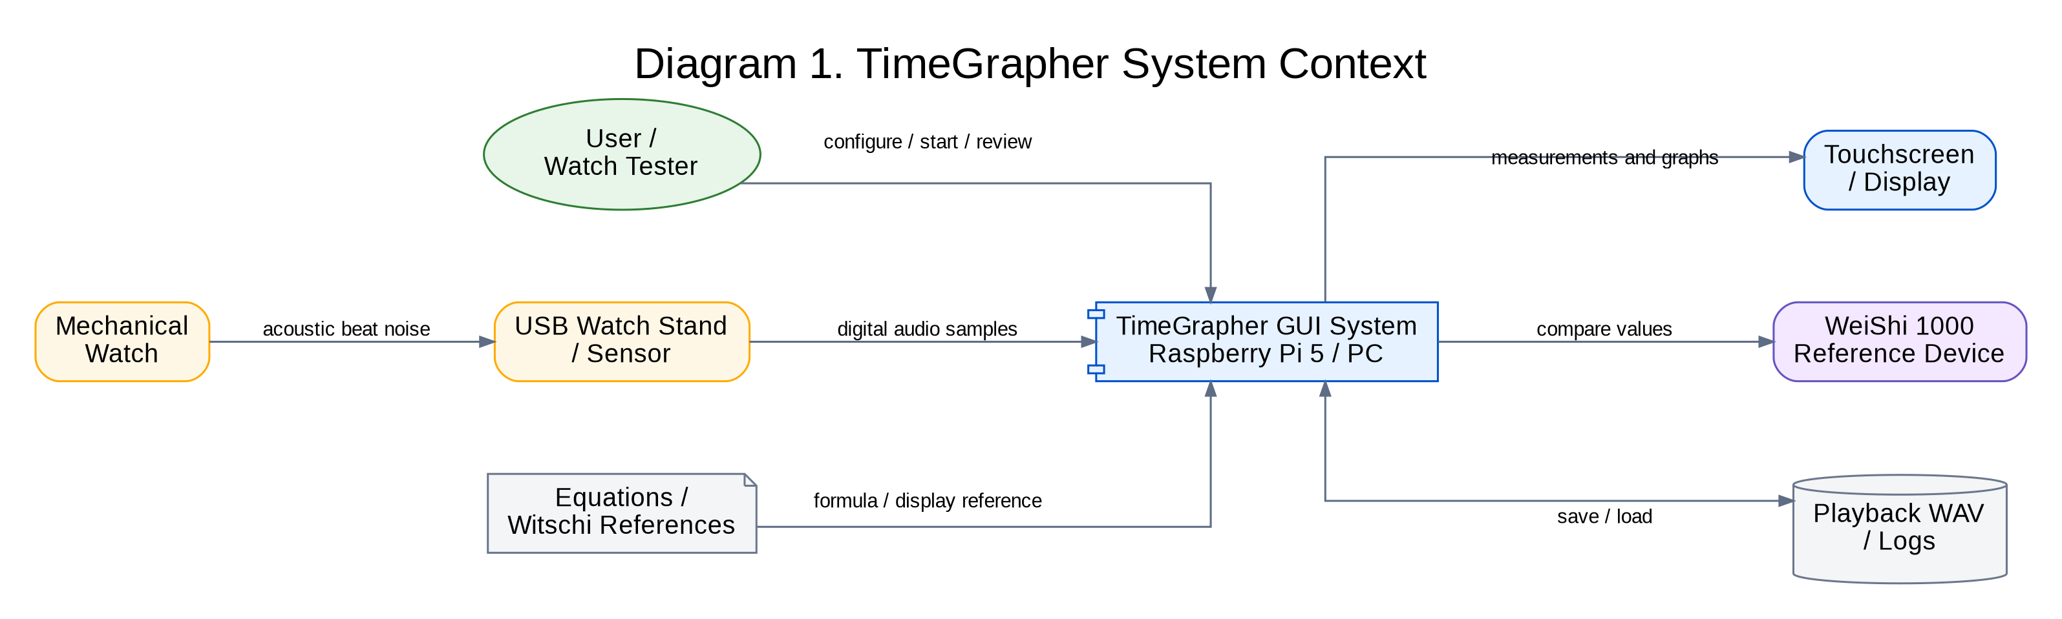
Diagram 1. System Context Diagram

14.2 Use Case Scope Diagram
Clarifies the functional scope from the user perspective while keeping the diagram readable for M1 planning.
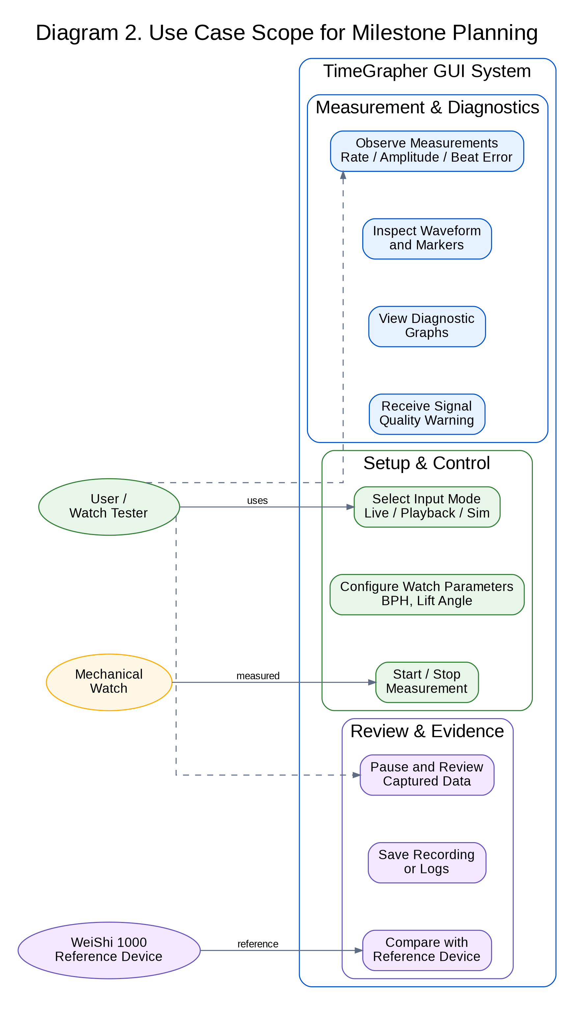
Diagram 2. Use Case Scope Diagram

14.3 Architecture Pipeline Diagram
Defines the first vertical slice and the main separation of responsibilities.
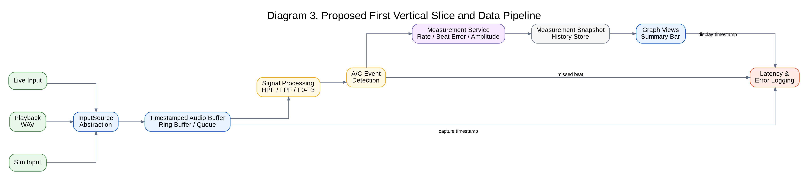
Diagram 3. Architecture Pipeline Diagram

14.4 As-Is vs To-Be Structure
Shows the main refactoring direction: reduce MainWindow concentration and separate pipeline responsibilities.
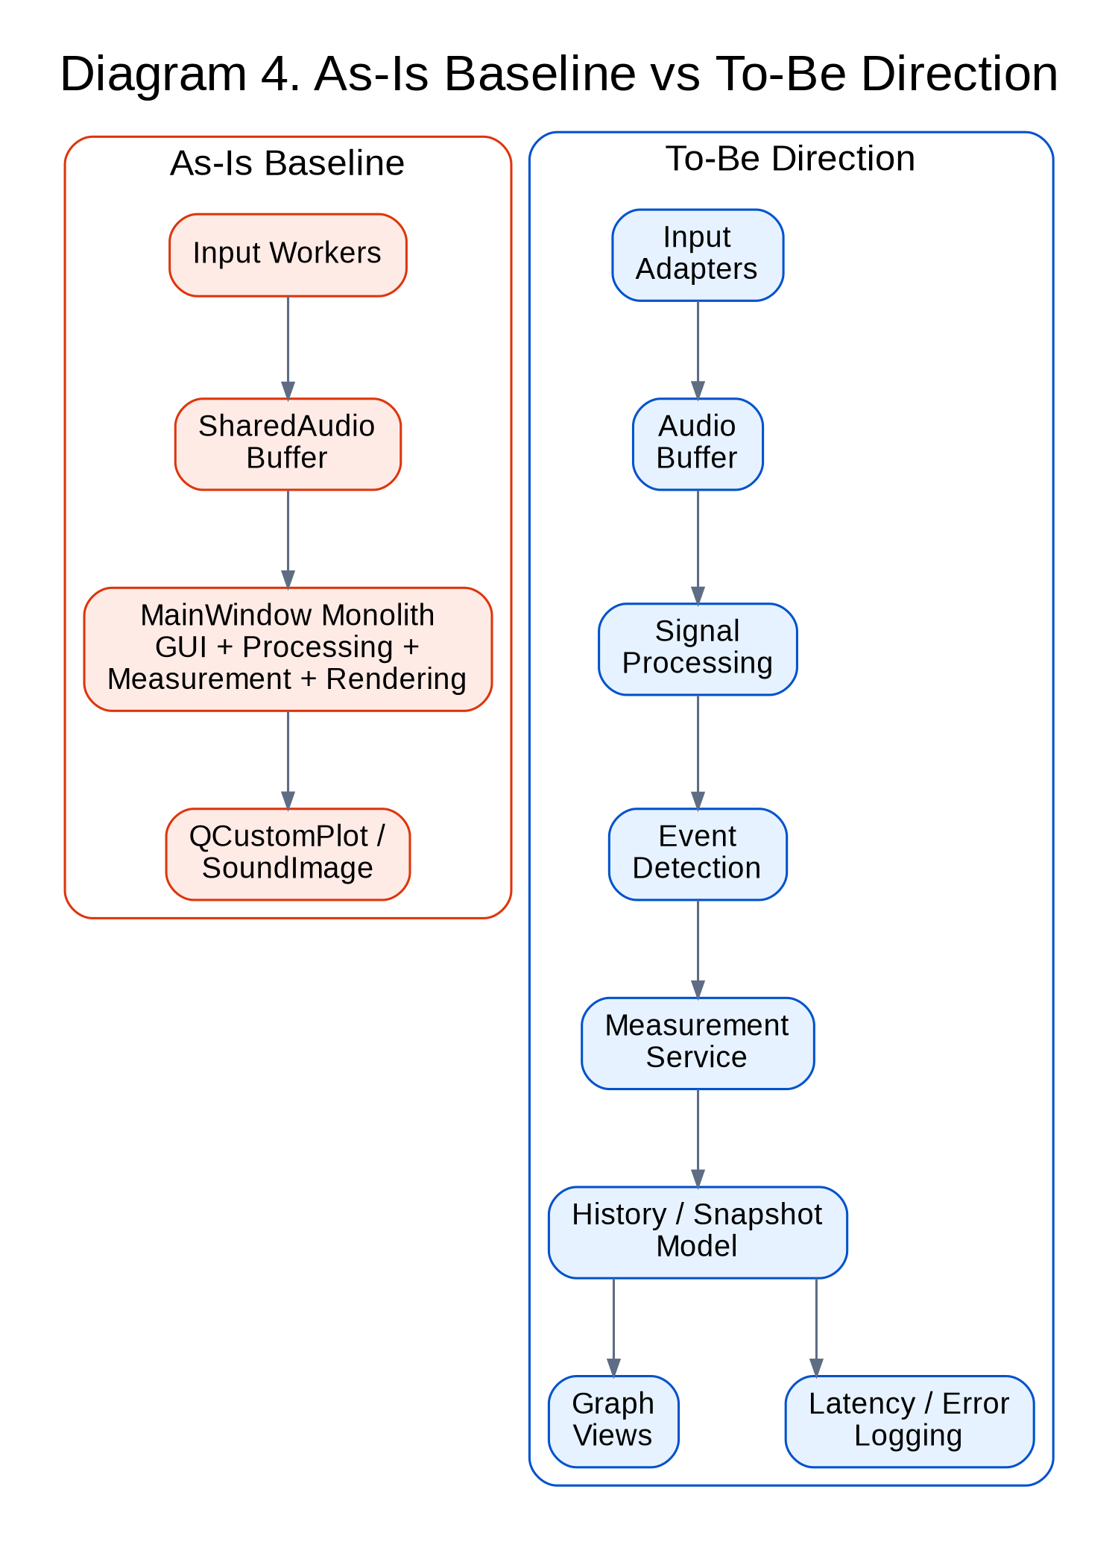
Diagram 4. As-Is vs To-Be Structure

14.5 Deployment Sketch
Summarizes the physical target environment and supporting development/reference devices.
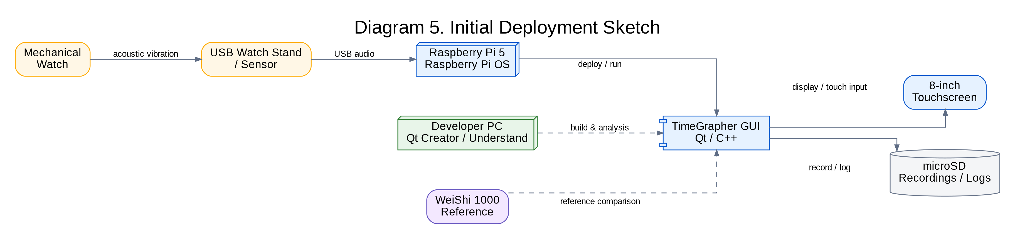
Diagram 5. Deployment Sketch

14.6 Milestone 1 Traceability Flow
Documents how requirements, quality attributes, risks, experiments, and ADRs are connected.
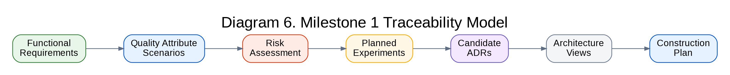
Diagram 6. Milestone 1 Traceability Flow

14.7 Understand Code Analysis Workflow
Explains how Understand analysis supports As-Is architecture, risk identification, and ADR planning.
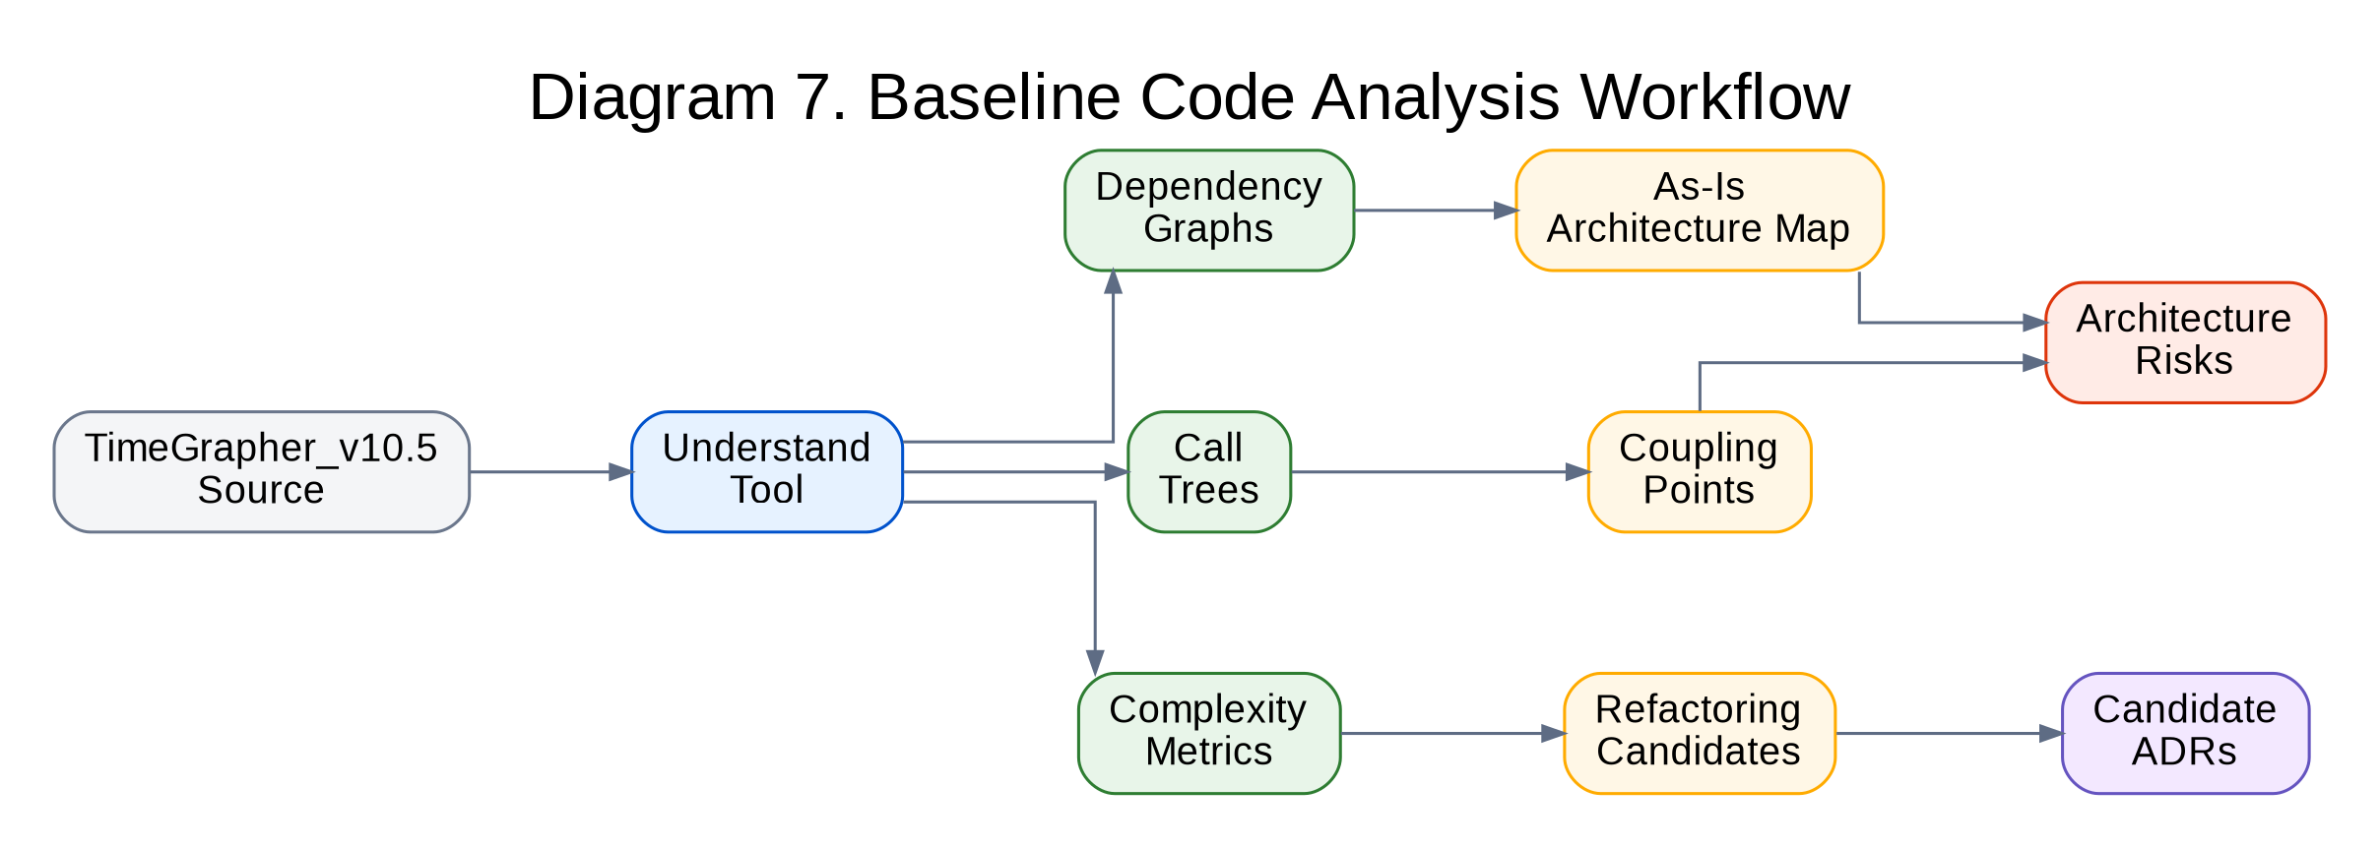
Diagram 7. Understand Code Analysis Workflow

15. Mermaid Source Availability
Editable Mermaid source for the diagrams was exported as a companion Markdown file. The Word document contains rendered diagram images for stable viewing and review; the Mermaid source can be used for later edits in Mermaid-compatible tools.
Diagram | Purpose
System Context Diagram | Shows the TimeGrapher boundary, external devices, references, and user interactions.
Use Case Scope Diagram | Clarifies the functional scope from the user perspective while keeping the diagram readable for M1 planning.
Architecture Pipeline Diagram | Defines the first vertical slice and the main separation of responsibilities.
As-Is vs To-Be Structure | Shows the main refactoring direction: reduce MainWindow concentration and separate pipeline responsibilities.
Deployment Sketch | Summarizes the physical target environment and supporting development/reference devices.
Milestone 1 Traceability Flow | Documents how requirements, quality attributes, risks, experiments, and ADRs are connected.
Understand Code Analysis Workflow | Explains how Understand analysis supports As-Is architecture, risk identification, and ADR planning.

